AI Camera 2.0 Basic Projects

Lesson 7: Smart Parking System
Ages: 12 and up
Duration: 45 minutes

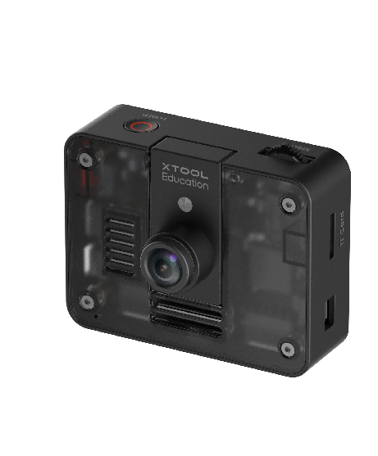

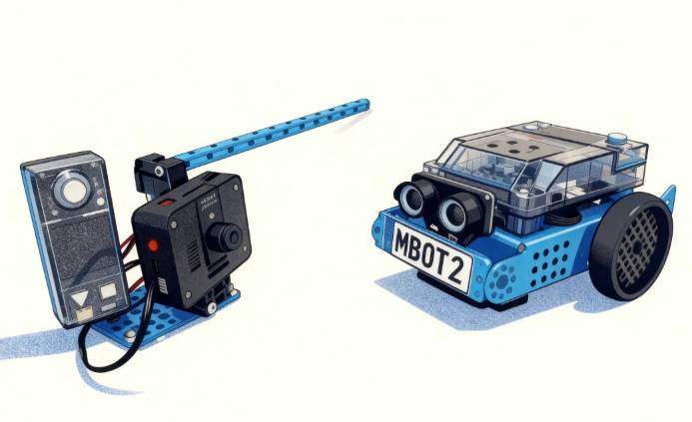
Objectives:
By the end of class, students will be able to:
- Understand the basic principles of text recognition
- List practical application scenarios of artificial intelligence and computer vision
- Master core programming concepts of events and conditions

Overview
This course uses a smart parking system as the application scenario to guide students in exploring the text recognition functionality of the AI Camera. Students will learn how to configure text recognition parameters and write programs enabling the system to make corresponding gate control decisions based on recognized license plate numbers. Through this project, students will understand the fundamental principles of text recognition technology and experience the practical application of artificial intelligence in intelligent transportation systems.

Pre-lesson Checklist
For the teacher:
- Computer with mBlock installed and tested;
- Adequate number of mBot2 robots (fully charged);
- License plates;
- AI Cameras compatible with mBot2;
- CyberPi and connection cables;
- Servo module (simulating gate opening/closing);
For the students:
- Computer with mBlock installed and ready;
- mBot2 robot and AI camera set per group;
- CyberPi and connection cable;
- Pre-made license plate samples (authorized and unauthorized plates);
- Servo module;
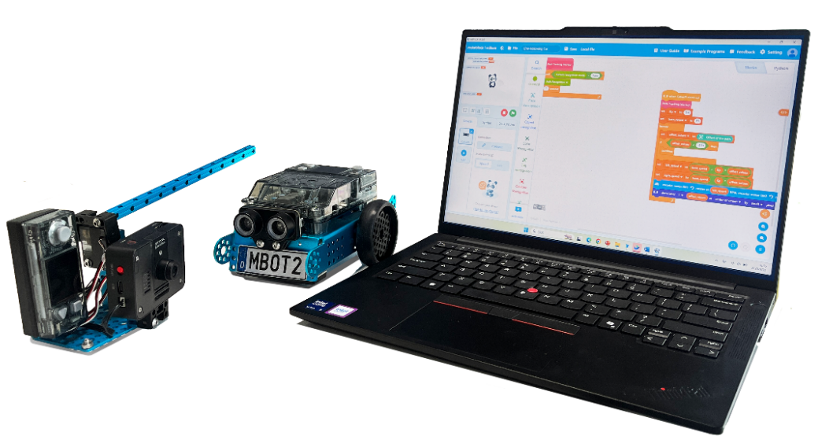

Agenda (45minutes)
Duration | Content
5 minutes | Section 1 - Introduction  - Demonstrate how the smart parking system automatically recognizes license plates and controls gate operation;
10 minutes | Section 2 - Explore  - Understand the basic principles of Optical Character Recognition (OCR);
15 minutes | Section 3 - Create and practice  - Set up the programming environment and activate text recognition function;  - Program to achieve license plate text recognition and result display;  - Design control logic for the smart parking gate system;
10 minutes | Section 4 - Presentation  - Invite 2-3 groups of students to demonstrate their smart parking systems;  - Discuss application prospects of text recognition technology in intelligent transportation and other fields;
5 minutes | Section 5 - Evaluate  - Review the problems they met and how they solved;  - Explore other potential application scenarios for text recognition technology;

Activities

Section 1 - Introduction
In today's lesson, we will explore how to use the AI Camera's text recognition technology to build a smart parking management system. When the camera recognizes an authorized license plate number, the gate automatically opens with a green light indicator; when an unauthorized plate is detected, the gate remains closed with a redlight indicator. How is this text recognition technology implemented? Let's begin today's exploration journey.

Section 2 - Explore
Optical Character Recognition (OCR) technology enables computers to "read" text in images through a three-step process: first, text detection and positioning locate areas containing text within the image; second, character segmentation separates individual characters within these text regions; finally, character recognition extracts features and classifies each character for identification.

Section 3 – Create and practice
In this section, students will work in groups to build a complete smart parking management system through hands-on practice.
Step 1: Set up programming environment and activate ORC. Add the [AI Camera 2.0] and [Pocket shield] extension modules in mBlock. Write an initialization program to configure text recognition parameters, including recognition results and the position of text on the screen. | 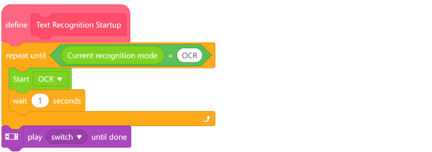
Step 2: Program license plate recognition. Use the text recognition module to extract text content from the camera feed. Define gate opening and closing operations based on the recognition results. | 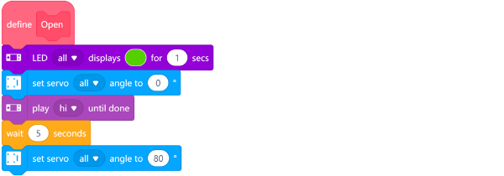
Step 3: Design gate control logic. Compare recognition results using conditional statements: When an authorized license plate is detected, control the servo to rotate to the "open" position and turn on the green light; When an unauthorized license plate is detected, keep the servo in the "close" position and turn on the red light. | 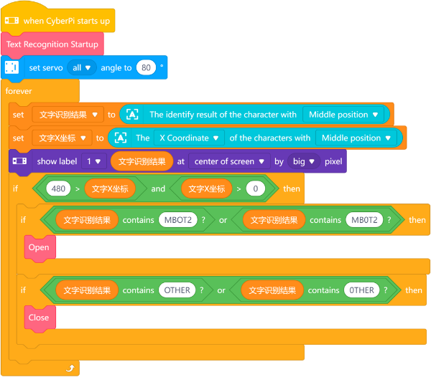

Section 4 - Presentation
In this session, students are invited to present and compare their group project outcomes. During demonstrations, please focus on the following aspects: The accuracy and response speed of text recognition and the commands designed for their smart parking system.
After 2-3 groups have presented, the teacher will facilitate a class discussion. Consider the following: What innovative approaches did different groups adopt in their system designs? What are the potential applications of text recognition technology in intelligent transportation and other fields?

Section 5 - Evaluate
Now let's review some key points in this lesson.
- What was the biggest challenge your team faced in today’s project, and how did you overcome it together?
- How might text recognition technology evolve in the future, and what changes could it bring to urban development?

